The Insight to Mate in 2:
- The second move must be a check, the first move can be either a check or not a check.

- If the first move delivers a check, then the piece delivering the first check will be the only piece covering the square the King originally is on after the King moves to another square. So the second move will either be another piece delivering the check with the original piece covering the original square or the same piece delivering the check without losing the cover of the square that the king was originally on.

This insight eliminates a great range of possibilities when you check with the same piece twice, cause the second move cannot lose the covering of the original square that the King was on.

- In most cases you have to check on the first move, otherwise if the King moves to another square you won’t be able to cover the original square.

If the only move that Black makes is a King move, and you didn’t check on the first move:
  - Most often it is a Queen move that makes direct contact with the King so that it can cover the original square, however, it can also be a Rook, Bishop, Knight check, but it has to be in a very specific scenario. (Most of the scenarios where Rook and Bishop can deliver the checkmate, the Queen can deliver it too)

And making direct contact with the King to cover both square is the special advantage that Queen offers to cover both squares, Queen has a variety of ways to deliver the same checkmate than its counterparts Knight, Bishop, or Rook can do.

(Sometimes it is even not making direct contact, but anyway, Queen offers a more varieties to deliver checkmate, I mean sometimes it is a diagonal contact such as this one)

In other words, if you cannot make a check that covers the original square and the square that King newly moves to, you have to consider checking on the first move.

3.2 If you consider using your Queen to make a direct contact with the enemy King on the second move, and the Queen check is support by a Knight, it would be impossible if the Knight is not supported itself.

So usually if you want to check with the Queen on the second move supported by a Knight, you generally want your knight to be supported by itself, so you can first consider a Knight move that will get itself supported.
-----------------
For Question 350

(The key to this puzzle is that the first move has to be a check, so when checking with the second move, the King won't have the chance to move back to the original square. If you don't check on the first move, then you will have to use your Queen to check on the second move so that it covers the original square and the square the King newly moves to, usually the second move has to be a move that Queen makes a direct contact with the King.

The Key is to sacrifice the Knight, Qc2!+, the forcing move is Kxe3, then followed by Bg1#.)
- The direction you push(a better word is nudge) the King to is very important. Generally, you don’t want to push the King to the direction where you don’t have a lot of cover, and the opposite is true, you want to push the King to position where you have a lot of cover. So if there is a piece covering the squares from the direction you don’t want the enemy King moves to, you have to think twice before you move that piece, or at least make sure you are not allowing the King to escape.

- If you are not checking the King on the first move, the second move should still be a check on the original square and every possible square that King can move to(could be met by a different check for every different move).
For this is the case for Q365
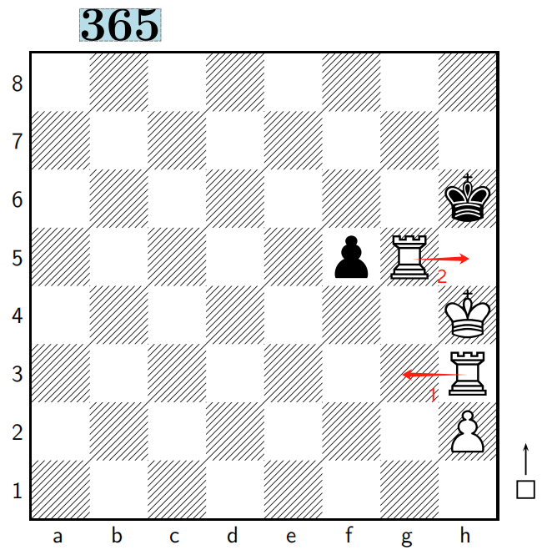

Insight for Q394:
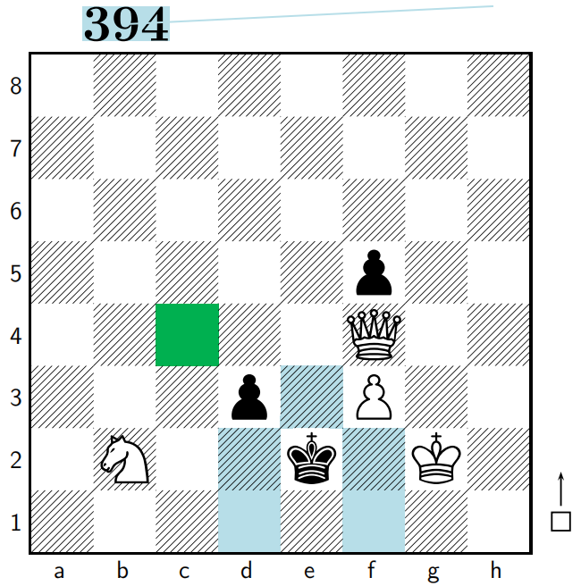

The Knight's control of the d1 square is not that valuable, and because Black has a pawn on d3, the King cannot move to d3 on the next move, in this case the Knight's control of a square(d2 square) that Queen can access later is more important. so Nc4, followed by Qd2#.

Reflection on the thinking process:
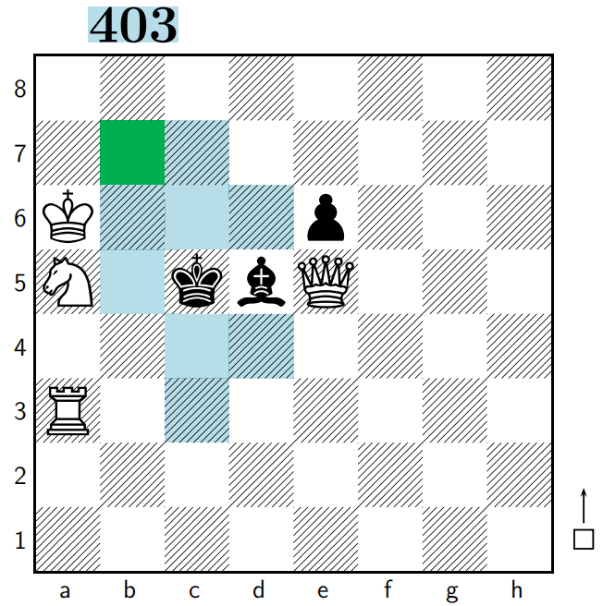

We consider that it can't either be a King move or a Knight move, considering the possibility of Kb4 on the second move, Queen will have to cover both c5 and b4 square, only possible move that leads to checkmate is Qc3#, which means both b5 and a4 squares have to be covered by the King and the Rook, it is unlikely to be a Queen move either, cause Queen move will increase the complexity greatly by allowing Bishop and pawn to move on the second move. There are only several possible Knight moves, then we conclude it is Nb7, giving up b4 and b6 squares for King, but can meet both of them with checkmate.

